**Lab assi-4**

**1.created product_master table & inserted the records.**

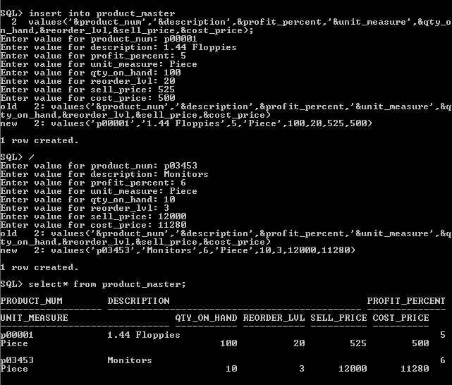

**2.Created sales order table and inserted records.**

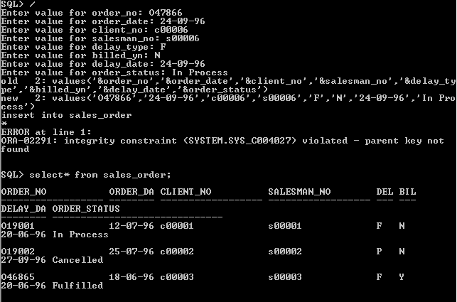

**3.Created sales order details table and inserted records.**

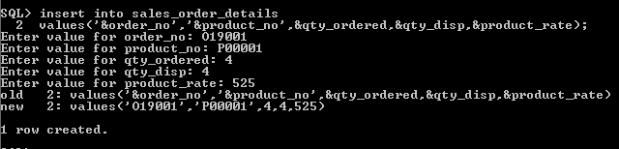

**Now fire sql queries from the above tables…….**

**4.Answer**

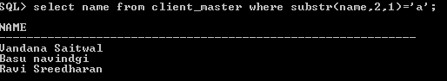

**5.Answer**

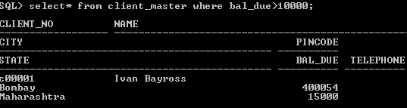

**6.Answer**

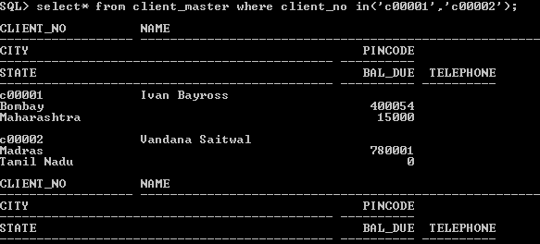

**7.answer**

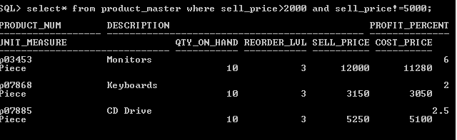

**8.answer**

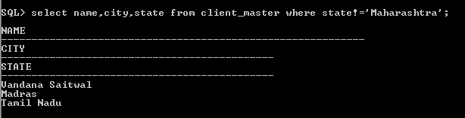

**9.answer**

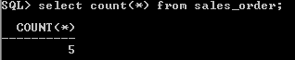

**10.answer**

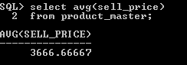

**11.answer**

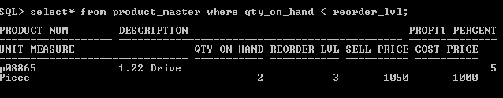

**12.answer**



**13.answer**

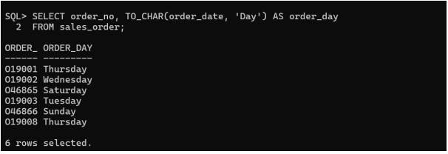

**14.answer**

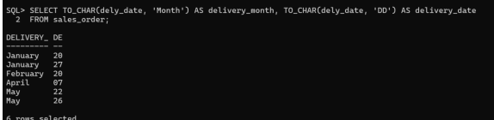

**15.answer**

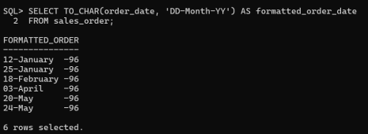

**16.answer**

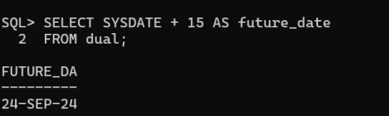

**17.answer**

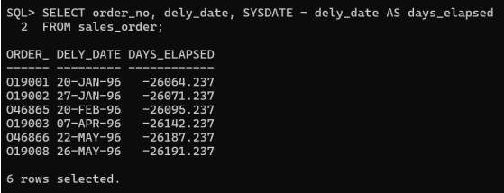

**18.answer**

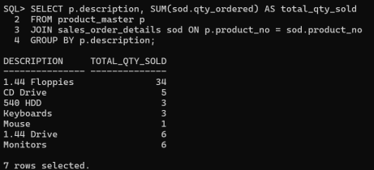

**19.answer**

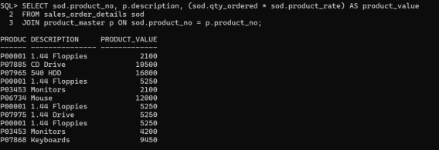

**20.answer**

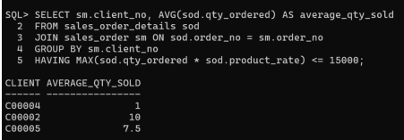

**21.answer**

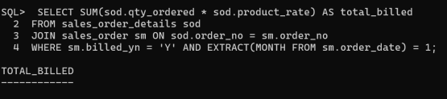

**22.answer**

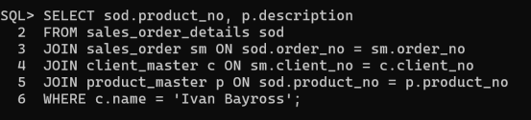

**23.answer**

